Case for Endorsement
BIM (Building Information Modelling) Awareness Project
CPC Construction, Plumbing & Services Training Package
Release 8.0

Submitted by Artibus Innovation on behalf of the
Construction, Plumbing and Services IRC, August 2020
Version 1

Artibus Innovation
Artibus Innovation is the Skills Service Organisation (SSO) supporting the Industry Reference Committees (IRCs) for the Construction, Plumbing and Services, and Property Services sectors in Australia. It develops, manages, and supports nationally recognised Training Packages.

The IRCs are responsible for providing guidance, direction, and advice in relation to the workforce training and skills development needs of these two industry sectors. Together, industry, employees and enterprises contribute significantly to Australia’s infrastructure, underpinning the nation’s economic and social fabric.

Acknowledgement of Support
Artibus Innovation is funded by the Australian Government Department of Education, Skills and Employment through the Training Product Development Program.

© Artibus Innovation, 2020

Case for Endorsement

BIM (Building Information Modelling) Awareness

August 2020

Contents

Executive Summary 4
A. Administrative details of the Case for Endorsement 8
B. Description of work and request for approval 10
C. Evidence of Industry support 17
D. Industry expectations about training delivery 18
E. Implementation of the new training packages 20
F. Quality assurance reports 21
G. Implementation of COAG Industry Skills Council reforms to training packages 42
H. Proposed training package components 44
Appendix A: Industry stakeholders 45
Appendix B: Stakeholder feedback and SSO response 52
Appendix C: Letters of support 69

Executive Summary

Project overview
Building Information Modelling (BIM) is the digital representation of a building which includes all information on the building through its whole life cycle from design, to build, to operations and even demolition. BIM allows professionals across the built environment – from construction to property management and maintenance – to access construction and operational information about the building.

BIM has been shown to have major benefits for the construction industry, including reliable cost estimates; early assessment of potential issues and design errors; tracking of construction activities; site safety planning and better communication and collaboration between project owners, designers, subcontractors and site workers. In Australia, BIM adoption is increasing. Tier One companies are already well advanced in BIM use and are starting to require sub-contractors to be able to interact with this technology. Despite this demand, BIM is poorly understood by a majority of construction workers and there are currently no units of competency in the CPC Construction, Plumbing and Services Training Package to address this skills gap.

On behalf of the Construction, Plumbing and Services Industry Reference Committee (IRC), Artibus Innovation prepared a proposal as part of the Construction, Plumbing and Services Industry Skills Forecast 2019 to develop a skill set in BIM awareness for the CPC Construction, Plumbing and Services Training Package. The project has developed a skill set and three units of competency aligned generally against Australian Qualifications Framework (AQF) level 4, to provide the competencies needed by builders, tradespersons, project and site managers to work on construction projects that incorporate BIM interaction, collaboration and deliverables.

The proposed components will provide nationally-recognised training to meet the growing demand for job-relevant BIM skills and knowledge that can be applied across multiple occupations and sectors of the construction industry. Packaging of the units as general electives in the CPC40120 Certificate IV in Building and Construction and CPC50320 Diploma of Building and Construction (Management) qualifications, and their presentation as a skill set in CPC Construction, Plumbing and Services Training Package, meets stakeholder demand for training that is accessible to different learner cohorts and via multiple learning pathways.

Industry engagement and consultation
Artibus Innovation promoted the project and its consultation processes to industry and other stakeholders using various engagement strategies such as meetings, phone discussions, emails, surveys, newsletters and a dedicated website project page. A Technical Advisory Group (TAG) was established to guide and promote the project and provide technical input into the proposed Training Package components. Direct consultation was held with 217 stakeholders, including 65 employer representatives and 129 Registered Training Organisations (RTOs).

An initial industry-wide survey was used to gather information to clarify the target audience and unit of competency functions that would best meet industry needs. Two national stakeholder consultation phases followed, with feedback used to refine and validate unit design, outcomes and content. These consultation processes included two online surveys and a webinar.

Engagement with construction employers was keenly sought given the need to ensure that the draft components were applicable to the workplace and relevant to the job roles of workers requiring BIM awareness training. BIM adoption in Australia currently tends to be the domain of large, national construction companies, and the components cover new workplace functions. This meant that accessing people suitably qualified to give feedback relevant to the workplace context was somewhat challenging, however, engagement was successful with representatives of a number of major players, including Hansen Yuncken, Multiplex, John Holland, Lend Lease, Built, Probuild and Mirvac.

Project sensitivities and issues
Feedback was overwhelmingly supportive of the draft components, confirming that the functional design, technical content and alignment to AQF 4 is appropriate for the intended audience and meets industry demand for BIM awareness skills and knowledge. It also confirmed that there is significant demand for BIM education in the construction industry.

Some issues were raised by stakeholders and these informed changes to unit content, for example, modifications that ensured the BIM skill and knowledge demands did not exceed the expected responsibilities of construction workers on site, and the need to make digital literacy requirements explicit in the units. Also, the need to ensure that the units focused on using BIM as a communication/workflow tool rather than focusing on the more advanced functions of proprietary software. Sensitivities and issues of note are highlighted below.

Sensitivity | Issue raised | IRC/TAG Response
- Digital literacy demands of the units of competency | Digital literacy provides the basis for the competencies and therefore requirements for digital literacy need to be made explicit.  Some workers may not have the technology skills required to complete the units. | Digital literacy advice/requirements have been made explicit in the units.  The technology demands of the units are to use software via information and communication technology (ICT) including applications on mobile devices to find, retrieve and communicate information. Feedback confirmed that while some may find this difficult, most construction workers have these skills.
- Challenges for implementation | Some learner cohorts will not have the literacy skills required for the units at the Certificate IV level.  RTOs will need to invest considerable resources to get the units on scope, including training and assessment resources and BIM trainer/assessor expertise. | Units of competency will be packaged at the Certificate IV and Diploma levels and in a skill set to ensure the units are accessible to different learner cohorts.  RTOs scoped to deliver CPC40120 Certificate IV in Building and Construction and CPC50320 Diploma of Building and Construction (Management) will not need to apply for additional scope.  Given the expected industry demand for the draft components, several RTOs have already indicated willingness to deliver the units.

Key outcomes
The outcomes of the project align with the Australian Industry and Skills Committee (AISC) requirements articulated in its activity order and support the implementation of Council of Australian Governments (COAG) reforms to Training Package components.

Unit of competency
Three new units of competency to be listed as general electives in the CPC40120 Certificate IV in Building and Construction and CPC50320 Diploma of Building and Construction (Management) qualifications:
- CPCBIM4001 Plan to comply with BIM requirements for construction work
- CPCBIM4002 Use BIM processes to carry out construction work
- CPCBIM4003 Contribute to BIM deliverables for construction work

Skill set
One new skill set:
- CPCSS00006 Apply BIM Processes to Construction Work Skill Set.

A. Administrative details of the Case for Endorsement

Name of allocated Industry Reference Committee (IRC)
The submission of this Case for Endorsement is made by the Construction, Plumbing and Services Industry Reference Committee (IRC).

Name of Skills Service Organisation
Artibus Innovation

Training Package components submitted for approval
This Case for Endorsement puts forward three units of competency and one skill set for inclusion in the CPC Construction, Plumbing and Services Training Package.

Units of competency - new
Unit Code | Unit Title
CPCBIM4001 | Plan to comply with BIM requirements for construction work
CPCBIM4002 | Use BIM processes to carry out construction work
CPCBIM4003 | Contribute to BIM deliverables for construction work

Skill sets - new
Skill Set Code | Skill Set Title
CPCSS00006 | Apply BIM Processes to Construction Work Skill Set

Further mapping information on the units of competency and skill set can be located in Section H: Proposed Training Package components

Case for Change details
On behalf of the Construction, Plumbing and Services IRC, Artibus Innovation prepared a proposal as part of the Construction, Plumbing and Services Industry Skills Forecast 2019 to provide a BIM awareness skill set.
Activity Order number: TPD/2018-19/002-4
Activity start date: May 2019
Original finish date: May 2020
Activity finish date: August 2020

Requirement set by the Australian Industry and Skills Committee (AISC) in relation to the training package activity
The Training Package development work commissioned by the AISC was to develop a new BIM awareness skill set:
- Introduction to Building Information Modelling *
- a total of three new units of competency.
* Note: consultation and development work confirmed that the skill set should be titled “Apply BIM processes to construction work” which better reflects the workplace and training outcomes and consistent with title formats of other skill sets in CPC Training Package.

B. Description of work and request for approval
This section describes the strategies used to promote the project to industry and key stakeholders, the specific methods used to gather and analyse feedback, and how the Technical Advisory Group (TAG) made informed decisions to ensure the units of competency meet the current and future needs of industry and key stakeholders.

Description of work undertaken and why
Building Information Modelling (BIM) is an emerging technology in the construction industry with demand for familiarity and experience of BIM uses and technologies in the building or construction context increasing across many occupations, particularly for construction project managers. BIM adoption in Australia is increasing, however, BIM is poorly understood by the majority of construction workers with BIM expertise typically limited to specialists. A skills gap is likely to emerge if the demand for BIM skills and knowledge more broadly across the construction workforce is not met.

This project developed three new units of competency to provide a BIM awareness skill set within CPC Construction, Plumbing and Services Training Package. The units will provide BIM skills and knowledge for a broad range of construction workers ranging from tradespersons through to builders and site and project managers. To ensure accessibility to these stakeholders, units will be packaged within CPC Construction, Plumbing and Services Training Package in two ways:
- the units will be listed as general elective units in the CPC40120 Certificate IV in Building and Construction and CPC50320 Diploma of Building and Construction (Management) qualifications
- the units will be presented as a skill set.
These packaging arrangements will accommodate the differing needs of potential learners, including existing workers requiring upskilling and new entrants via the Certificate IV and Diploma qualifications.

The work was overseen by the Construction, Plumbing and Services IRC and guided by a TAG comprising members recommended and selected based on their expertise in BIM and their connections with industry. The IRC appointed a member of its committee to Chair the TAG and that Chair reported back to the IRC in its quarterly meetings by way of a project brief and verbal reports.

Formation of a Technical Advisory Group (TAG)
A TAG was established to provide guidance on the development of BIM units of competency and to promote consultation processes via their industry networks. TAG membership included representatives from industry associations, training providers and industry practitioners (employers and employees) as shown below.

TAG Member | Organisation
Stuart Maxwell * (Chair) | Construction, Forestry, Maritime, Mining and Energy Union (CFMMEU) & IRC member
Robert Booth | TasTAFE
Stewart Caldwell | Russell & Yelland Architects
Martine Cason | TAFE WA
Will Joske | Swinburne University
Jennifer Lawrence * | Master Builders Australia (MBA) & IRC member
David Roberts | Hutchinson Builders
Teresa Serrao | Built Form Design Academy
Shannon Thomas | Air Conditioning and Mechanical Contractors' Association (ACMCA)
* Note: Stuart Maxwell replaced the initial IRC-appointed Chair, Marie Paterson; and Jennifer Lawrence replaced the initial MBA appointee, Adam Profke.

The TAG convened on four occasions to discuss options and issues related to the design and technical content of the BIM units as well as project consultation processes and stakeholder feedback. A summary of meetings and TAG discussion is provided below.

TAG Meeting | Key discussion and actions
Meeting 1:  29 October 2019 (Adelaide) | - Introductions and project overview  - Discussion of project objectives, potential learner cohorts and BIM skill and knowledge requirements to meet industry demand now and into the future  - Presentation from David Morgan on lessons learnt from Singapore and Malaysia after 11 years of BIM implementation  - Agreement that the target audience for BIM awareness training and functional coverage of the proposed units needed to be defined, and an industry survey would be conducted to clarify industry’s immediate training requirements
Meeting 2:  13 May 2020 (online) | - Discussion of industry survey results  - Discussion of, and support for the design rationale for the first draft of units based on Australian Qualifications Framework (AQF) 4 and targeted at learners ranging from tradespersons to builders and site and project managers  - Discussion of, and advice provided on, unit structures and technical content including an agreement that no prerequisites are required nor licensing, legislative, regulatory or certification requirements  - Agreement that performance evidence requirements would be finalised and approved out-of-session to produce draft pack one  - Agreement to proceed to national stakeholder consultation and to promote consultation processes via TAG networks
Meeting 3:  23 June 2020 (online) | - Discussion of the results and feedback from stakeholder consultation on draft pack one  - Recommendations on actions to be taken to update units based on stakeholder feedback and issues raised  - Agreement that units would be updated and approved out-of-session to produce draft pack two  - Agreement to proceed to national stakeholder validation and to promote the validation processes via TAG networks
Meeting 4:  15 July 2020 (online) | - Discussion of the results and feedback from stakeholder validation of draft pack two  - Recommendations on actions to be taken to update units based on stakeholder feedback and issues raised  - Agreement that units would be updated and approved out-of-session to produce draft pack three  - Noted that the IRC will decide on the most appropriate packaging of units within CPC Construction, Plumbing and Services Training Package  - Agreement to facilitate letters of support from industry via TAG networks  - Noted and approval of next steps to complete the project

Industry and stakeholder consultation
Consultation overview
Multiple opportunities to participate in general and targeted consultations were offered to industry and other stakeholders using various engagement strategies. Artibus Innovation promoted consultation processes through its newsletter and social media, and TAG members through their networks. Feedback was received from a wide range of stakeholders, including industry representatives, construction design/BIM specialists, industry associations, RTOs, unions and interested government bodies, and used as the basis for the design and development of the BIM awareness skill set.

At its initial meeting, the TAG identified the need to canvass industry via an online survey to clarify the target audience for the new skill set as well as unit of competency functions that would best meet industry requirements for BIM awareness training. The survey was open for two months, however yielded only seventeen responses. While none of these were from construction employers, they did provide key insights into current BIM use and topics considered important for VET training.

In February 2020, a meeting was held with representatives of the Box Hill Institute (BHI) in Victoria involved in developing a Victorian qualification in BIM (22507VIC Advanced Diploma of Building Information Modelling (BIM)). This qualification is currently undergoing a one-year trial with free enrolment. The main objective of the meeting was to learn about the BHI course and issues associated with its development, and to find synergies to ensure that this project did not duplicate BHI outcomes. Discussions with the BHI team indicated there is a significant gap between Certificate III graduates and the Advanced Diploma. BHI indicated a willingness to work with Artibus to ensure the outcomes of both projects were complementary and offered to assist survey dissemination to their BIM contacts. This meeting supported initial feedback and research that developing awareness units targeted at construction workers operating at the AQF 4 level would best meet industry needs.

Three major consultation processes were implemented to inform industry and stakeholders of project progress and gather data and feedback as the basis for development work.

Process | Key objectives and outcomes
Industry-wide survey | An industry-wide survey was made available for two months from 2 December 2019 to the end of January 2020 to seek information to clarify the target audience for the new skill set as well as unit of competency functions that would best meet industry requirements for BIM awareness training. Seventeen responses were received providing the following key information:  - BIM use is increasing, especially for government projects and improves collaboration, error checking, services coordination etc.  - industry is demanding students have good BIM knowledge and clients are expecting more advanced models in the early phases of projects  - 3D modelling is done on all larger projects now, but the level of detail associated with 4D and 5D is increasingly required  - VET training is needed to understand and use BIM with the following topics important:  - scheduling and sequencing of construction work  - understanding cost management and procurement using BIM  - identifying and managing risk and applying standards in a BIM environment  - model checking and review (quality assurance, clash detection etc.)  - interrogating, reading and interpreting models  - defining expectations of BIM outputs  - strategies are in place to improve BIM capability - new workers do not have the required skills.
National Stakeholder Consultation | Draft pack one of the units of competency was made available to industry and stakeholders nationally for four weeks from 19 May to 16 June 2020. Feedback was received via an online survey and through email and phone discussions with the project manager:  - fourteen survey responses were received (including six employer and four RTO responses)  - overall, feedback was supportive of the unit design, target audience and AQF level  - detailed comments on technical content, performance criteria, performance evidence and knowledge evidence were used to develop draft pack two.
National Stakeholder Validation | Draft pack two was made available to industry and stakeholders nationally for two weeks from 25 June to 9 July 2020. Feedback was received via an online survey, webinar and through emails and phone discussions with the project manager:  - fourteen survey responses were received (including six employer and four RTO responses)  - seven people attended an online webinar on 8 July 2020 (including one employer, three Stat/Territory Training Authorities (STAs), one industry association and two RTO representatives)  - feedback was again fully supportive of the units with issues raised mainly relating to implementation  - detailed comments on technical content were used to refine the final draft units.
Engagement with construction employers was keenly sought given the need to ensure that the units were applicable to the workplace and relevant to the job roles of the construction workers who might undertake training using the skill set. This proved somewhat challenging as the units cover new workplace functions; BIM adoption in Australia currently tends to be the domain of large, national construction companies; and access to people suitably qualified to give feedback in the workplace context was limited. Nevertheless, consultation with representatives from the following major construction companies was achieved and resulted in overwhelmingly positive feedback that the units of competency were job-relevant and covered the essential BIM awareness skills and knowledge required by their workers:

- Hansen Yuncken  - Multiplex  - Lend Lease  - Probuild  - Built  - Mirvac | - John Holland  - ABS Façade  - Construction Control  - Geocon  - North Building and Construction.

At the conclusion of project activities, the stakeholder register had recorded targeted consultation with 217 stakeholders, including 65 employer representatives, 129 RTO representatives, 11 industry association and union representatives, and representatives from all STAs.

Strategies used to engage industry and stakeholders
Direct engagement
Face-to-face and online meetings, phone discussions and emails were used to target stakeholders and engage directly with employers, training providers, STA representatives and other key stakeholders. During the critical development and consultation periods of the project face-to-face consultation was not possible due to COVID-19 restrictions. Phone and online discussions were a preferred method of engagement and proved particularly beneficial in fostering mutual understanding and allowing questions and issues to be discussed and addressed.

Newsletter
Artibus Innovation newsletters were distributed a network of 4,000+ to promote the project and its processes at key stages. Five newsletters informed stakeholders of the current status of the project and provided links to feedback mechanisms.

Project page
To make information generally available to stakeholders, a project page was developed on the Artibus Innovation website. The project page was kept updated throughout the duration of the project, providing information on the status of the project and opportunities to download draft components and provide feedback: https://www.artibus.com.au/bim-awareness/
At the time of project submission, the project page had recorded over 2,300 visitors.

Surveys
Three online surveys were used at key consultation stages to provide stakeholders with opportunities to provide feedback on the project and have input into the draft components.

Validation webinar
An online webinar was held during the national stakeholder validation period. This consultation mechanism provided stakeholders with a key opportunity to clarify questions and issues related to the draft components and their implementation.

State/Territory Training Authority (STA) participation
Artibus Innovation has engaged with all STAs throughout the project, maintaining open dialogue and requesting feedback on draft components.

Consideration was given to specific STA feedback and individual STA members were contacted directly via phone, email, and online communication methods to address concerns and questions in the development of the Training Package components. An online meeting was held on 30 July 2020 as a key opportunity to brief STAs on project progress and clarify any questions or issues.

Dissenting views
There are no dissenting views to report.

Summary of feedback/issues
A full summary of stakeholder feedback and the SSO’s response is provided at Appendix B: Stakeholder feedback and SSO response.

Proposed key changes:
Below is a summary of the key changes being proposed following industry consultation and validation:

Key changes | Description
KC1 | Three new units of competency have been developed to meet industry needs:  - CPCBIM4001 Plan to comply with BIM requirements for construction work  - CPCBIM4002 Use BIM processes to carry out construction work  - CPCBIM4003 Contribute to BIM deliverables for construction work.
KC2 | One new skill set has been developed to meet industry needs:  - CPCSS00006 Apply BIM Processes to Construction Work Skill Set.
KC3 | Minor update of the CPC40120 Certificate IV in Building and Construction and CPC50320 Diploma of Building and Construction (Management) qualifications to include three new BIM units of competency in the listing of general elective units.

C. Evidence of Industry support
The Construction, Plumbing and Services IRC supports the submission of Training Package components put forward in this Case for Endorsement.

Signed by the appointed Chair of the Construction, Plumbing and Services IRC.

Name of IRC Chair: Stuart Maxwell

Signature of IRC Chair: __________________________________

Date: August 2020

State and Territory Training Authority responses to the Case for Endorsement

The project was put through the quality assurance process then sent to the STA’s for review and sign-off on August 2020.

D. Industry expectations about training delivery

Advice about industry’s expectations of training delivery
The new BIM skill set will have a wide impact across the construction industry. Industry and RTO stakeholders have consistently expressed the view that BIM adoption is increasing in Australia, however, BIM is not well understood by a majority of construction workers. There is a strong need for nationally-recognised training to enable construction workers to understand and apply BIM processes during the construction phase of BIM projects. Increasingly, builders are also becoming involved in BIM from the tendering phase of projects and planning for delivery, and throughout the duration of construction and the handover of digital assets.

The proposed components have been developed in close consultation with industry and stakeholders to:
- provide workplace outcomes that are relevant to the work performed by a range of construction workers who require BIM skills and knowledge
- provide units of competency that are accessible in content, format and logic
- support learner mobility within and across construction organisations and worksites
- support national implementation and delivery and assessment in a wide variety of contexts
- support sound assessment practice to ensure that assessment is fair, reliable and evidenced by knowledge, skills and work performance that meet agreed industry standards.

Given the opportunities offered to industry by ensuring multiple learning pathways, the units will be listed as general electives in the CPC40120 Certificate IV in Building and Construction and CPC50320 Diploma of Building and Construction (Management) qualifications. They will also be presented in a skill set “CPCSS00006 Apply BIM Processes to Construction Work Skill Set”.

Eleven letters of support in relation to the draft components are provided at Appendix C. These were submitted by:
- Robert Booth, Teacher, TasTAFE
- Martine Cason, Architect
- Lauren Couter, Director, Construction Control
- Michael Dunn, BIM Manager, Geocon Constructors
- Luke Gavioli, Queensland BIM & VDC Manager, Hansen Yuncken
- Will Joske, BIM Academy
- Brian Richards, Design Director, Built
- David Roberts, Building Services Manager, Hutchinson Builders
- Teresa Serrao, Built for Design Academy
- Nathan Smith, National Operations Manager, ABS Façade
- Shannon Thomas, Executive Manager BIM-MEP, Air Conditioning & Mechanical Contractors’ Association of Victoria Limited.

IRC recommendation on traineeships and apprenticeships
The Training Package development work proposed in this Case for Endorsement is not expected to have an impact on the use of traineeships and/or apprenticeships.

E. Implementation of the new training packages

Advice on occupational and licensing requirements
At the time of publication, no licensing, legislative or certificate requirements apply to the proposed components.

Implementation issues of note and management strategy
The proposed units of competency are new, developed to cover an emerging skills gap in the construction industry. As such, a number of implementation challenges for RTOs should be expected including the need to:
- apply to the Australian Skills Quality Authority (ASQA) for scope to deliver the units (where such scope is not already implicit due to the units being listed in the CPC40120 Certificate IV in Building and Construction and CPC50320 Diploma of Building and Construction (Management) qualifications)
- develop training and assessment resources to implement the units
- access suitably qualified trainers and assessors to comply with ASQA’s Standards for RTOs.

Guidance for RTOs will be included in the CPC Construction, Plumbing and Services Training Package Companion Volume Implementation Guide. RTOs may consider partnership arrangements with industry to access the expertise required for training and assessment. In addition, there are a number of free resources that would assist implementation. These are available via the NATSPEC (National Building Specification) BIM Portal (https://bim.natspec.org/). The website is home to the NATSPEC National BIM Guide and is a repository of documents and tools that will assist implementation of BIM in the construction industry.

Advice on downstream effects of the changes
The impact for enterprises and RTOs is expected to be a positive one. The proposed components will provide nationally-recognised training to meet the growing demand for job-relevant BIM skills and knowledge that can be applied across multiple occupations and sectors of the construction industry.

F. Quality assurance reports
An editorial report was undertaken by Trish Gamper.

Editorial Report Template
1. Cover page
Information required | Detail
Training Package title and code | CPC Construction, Plumbing and Services Training Package R8.0 (Building Information Modelling)
Number of new qualifications and their titles | Nil
Number of revised qualifications and their titles | Nil
Number of new units of competency and their titles | Three (3) new units of competency:  CPCBIM4001 Plan to comply with BIM requirements for construction work  CPCBIM4002 Use BIM processes to carry out construction work  CPCBIM4003 Contribute to BIM deliverables for construction work
Number of revised units of competency and their titles | Nil
Confirmation that the draft training package components are publication-ready | Draft components are publication ready
Is the Editorial Report prepared by a member of the Quality Assurance Panel? If ‘yes’ please provide a name. | Yes or No  Yes, Trish Gamper
Date of completion of the report | 5 August 2020

2. Content and structure

Units of competency
Editorial requirements | Comments
Standard 5:  - The structure of units of competency complies with the unit of competency template. | The structure of units of competency complies with the unit of competency template.
Standard 7:  - The structure of assessment requirements complies with the assessment requirements template. | The structure of the assessment requirements complies with the assessment requirements template.

Qualifications
Editorial requirements | Comments by the editor
Standard 9:  - The structure of the information for qualifications complies with the qualification template. | NA
Standard 10:  - Credit arrangements existing between Training Package qualifications and Higher Education qualifications are listed in a format that complies with the credit arrangements template. | NA

Companion Volumes
Editorial requirements | Comments by the editor
Standard 11:  - A quality assured companion volume implementation guide is available and complies with the companion volume implementation guide template. | A quality assured Companion Volume Implementation Guide was provided for editing and complies with the required template.

3. Proofreading

Editorial requirements | Comments by the editor
- Unit codes and titles and qualification codes and titles are accurately cross-referenced throughout the training package product(s) including mapping information and packaging rules, and in the companion volume implementation guide. | Unit codes and titles were cross-referenced throughout the Case for Endorsement and the Companion Volume Implementation Guide, including mapping information.
- Units of competency and their content are presented in full. | All units of competency and content were provided in full for editing.
- The author of the Editorial Report is satisfied with the quality of the training products, specifically with regard to:  - absence of spelling, grammatical and typing mistakes  - consistency of language and formatting  - logical structure and presentation of the document.  - compliance with the required templates | The editor is satisfied with the quality of the units of competency.  - Spelling, grammatical and typing mistakes were corrected, as required  - Language used and formatting is consistent throughout the units of competency  - The units of competency are logically structured and presented  - All components comply with the required templates.

An equity report was undertaken by Trish Gamper.

Equity Report Template

Section 1 – Cover page

Information required | Detail
Training Package title and code | CPC Construction, Plumbing and Services Training Package R8.0 (Building Information Modelling)
Number of new qualifications and their titles | Nil
Number of revised qualifications and their titles | Nil
Number of new units of competency and their titles | Three (3) new units of competency:  CPCBIM4001 Plan to comply with BIM requirements for construction work  CPCBIM4002 Use BIM processes to carry out construction work  CPCBIM4003 Contribute to BIM deliverables for construction work
Number of revised units of competency and their titles | Nil
Confirmation that the draft training package components meet the requirements in Section 2 Equity checklist of draft training package components | Draft Training Package components meet the requirements in Section 2 Equity checklist of draft Training Package components
Is the Equity Report prepared by a member of the Quality Assurance Panel? If ‘yes’ please provide the name. | Yes or No  Yes, Trish Gamper
Date of completion of the report | 5 August 2020

Section 2 – Equity checklist of draft training package components

Equity requirements | Equity reviewer comments  Provide brief commentary on whether the draft endorsed components meet each of the equity requirements
The training package component(s) comply with Standard 2 of the Standards for Training Packages 2012. The standard requires compliance with the Training Package Products Policy, specifically with the access and equity requirements:  - Training Package developers must meet their obligations under Commonwealth anti-discrimination legislation and associated standards and regulations.  - Training Package developers must ensure that Training Packages are flexible and that they provide guidance and recommendations to enable reasonable adjustments in implementation. | The draft CPC Construction, Plumbing and Services Training Package components meet the requirements of Standard 2 of the Standards for Training Packages 2012 and comply with the Training Package Products Policy.  The CPC Construction, Plumbing and Services Training Package Companion Volume Implementation Guide provides information relating to access and equity considerations and reasonable adjustments.  The draft CPC Construction, Plumbing and Services Training Package components provide sufficient flexibility and provide advice to enable reasonable adjustments to be made during implementation.

Section 3 - Training Package Quality Principles

Quality Principle 4
Be flexible to meet the diversity of individual and employer needs, including the capacity to adapt to changing job roles and workplaces.

Key features
Do the units of competency meet the diversity of individual and employer needs and support equitable access and progression of learners?
What evidence demonstrates that the units of competency and their associated assessment requirements are clearly written and have consistent breadth and depth so that they support implementation across a range of settings?
Are there other examples that demonstrate how the key features of flexibility are being achieved?
Equity requirements | Equity reviewer comments
1. What evidence demonstrates that the draft components provide flexible qualifications/units of competency that enable application in different contexts?’ | Three new units of competency were developed to provide a Building Information Modelling (BIM) awareness skill set within the CPC Construction, Plumbing and Services Training Package. The units will provide BIM skills and knowledge for a broad range of construction workers ranging from tradespersons through to builders and site and project managers. These units are also being included in the Certificate IV and Diploma qualification as general electives, providing flexible options for learners and employers.
2. Is there evidence of multiple entry and exit points? | NA
3. Have prerequisite units of competency been minimised where possible? | No units have prerequisite requirements.
4. Are there other examples of evidence that demonstrate how the key features of the flexibility principle are being achieved? | The Case for Endorsement notes that the draft units of competency have been developed in close consultation with industry and stakeholders and:  - provide multiple learning pathways through the new skill set as well as being included as general electives in the Certificate IV and Diploma  - provide nationally recognised training to meet the growing demand for job-relevant BIM skills and knowledge that can be applied across multiple occupations and sectors of the construction industry

Quality Principle 5

Facilitate recognition of an individual’s skills and knowledge and support movement between the school, vocational education and higher education sectors.

Key features
Support learner transition between education sectors.

Equity requirements | Equity reviewer comments
1. What evidence demonstrates pathways from entry and preparatory level as appropriate to facilitate movement between schools and VET, from entry level into work, and between VET and higher education qualifications? | No qualifications are being submitted for endorsement.

Quality Principle 6

Support interpretation by training providers and others through the use of simple, concise language and clear articulation of assessment requirements.

Key features
Support implementation across a range of settings and support sound assessment practices.

Equity requirements | Equity reviewer comments
1. Does the Companion Volume Implementation Guide include advice about:  - Pathways  - Access and equity  - Foundation skills?  (see Training Package Standard 11) | The Companion Volume Implementation Guide was reviewed and contains relevant advice on:  - Pathways  - Access and equity  - Foundation skills
2. Are the foundation skills explicit and recognisable within the training package and do they reflect and not exceed the foundation skills required in the workplace? | Foundation skills are explicit and recognisable in units of competency. Artibus Innovation have also identified them in the foundation skills section of the unit of competency. They do not exceed the skills expected in the workplace.

A quality report was undertaken by Anna Henderson.

Quality Report

Section 1 – Cover page
Information required | Detail
Training Package title and code | CPC Construction, Plumbing and Services Training Package  Release 8.0  Building Information Modelling (BIM) project
Number of new qualifications and their titles | -
Number of revised qualifications and their titles | -
Number of new units of competency and their titles | 3 new units:  - CPCBIM4001 Plan to comply with BIM requirements for construction work  - CPCBIM4002 Use BIM processes to carry out construction work  - CPCBIM4003 Contribute to BIM deliverables for construction work
Number of revised units of competency and their titles | -
Confirmation that the panel member is independent of:  - the Training Package or Training Package components review (‘Yes’ or ‘No’)  - development and/or validation activities associated with the Case for Endorsement  (‘Yes’ or ‘No’)  - undertaking the Equity and/or Editorial Reports for the training package products that are the subject of this quality report (‘Yes’ or ‘No’) | Yes, I am independent of:  - CPC R8.0 Training Package  - The development and validation activities  - The Equity and Editorial reports.
Confirmation of the Training Packages or components thereof being compliant with the Standards for Training Packages 2012 | Yes, the BIM project in the CPC Construction, Plumbing and Services Training Package R8 is compliant with the Standards for Training Packages 2012
Confirmation of the Training Packages or components thereof being compliant with the Training Package Products Policy | Yes, the BIM project in the CPC Construction, Plumbing and Services Training Package R8 is compliant with the Training Package Products Policy.
Confirmation of the Training Packages or components thereof being compliant with the Training Package Development and Endorsement Process Policy | Yes, the BIM project in the CPC Construction, Plumbing and Services Training Package R8 is compliant with the Training Package Development and Endorsement Process Policy
Panel member’s view about whether:  - the evidence of consultation and validation process being fit for purpose and commensurate with the scope  - estimated impact of the proposed changes is sufficient and convincing | Yes
Name of panel member completing Quality Report | Anna Henderson
Date of completion of the updated Quality Report | 7 Aug 2020

Section 2 – Compliance with the Standards for Training Packages 2012

Standards for Training Packages | Standard met  ‘yes’ or ‘no’ | Evidence supporting the statement of compliance or noncompliance (including evidence from equity and editorial reports)
Standard 1  Training Packages consist of the following:  - AISC endorsed components:  - qualifications  - units of competency  - assessment requirements (associated with each unit of competency)  - credit arrangements  - One or more quality assured companion volumes | Yes | The BIM component of the CPC Construction, Plumbing and Services Training Package R8 submission consists of the following endorsed components:  - 3 units of competency  - credit arrangements are discussed in the CPC Construction, Plumbing and Services Training Package R8 Companion Volume Implementation Guide (CVIG).  - A quality assured Companion Guide – CPC Construction, Plumbing and Services Training Package R8 CVIG.
Standard 2  Training Package developers comply with the Training Package Products Policy | Yes | The draft Training Package component comply with this Standard:  - Coding and titling –: the qualification and units of competency comply with the coding and titling policy.  - Foundation Skills not explicit in the Performance Criteria of the BIM units are listed in this section. The CPC Construction, Plumbing and Services Training Package R8 CVIG provides further explanation about foundation skills.  - Mapping - the mapping tables are found in the CPC Construction, Plumbing and Services Training Package R8.0 CVIG. This includes equivalence status of the endorsed components.  - Qualification packaging rules –the rules for the qualification are clear and practical and allow for packaging for a range of contexts.  - Qualification – occupational/pathway advice – occupation outcome advice for all Construction, Plumbing and Services Training Package occupations advice is included in the CPC Construction, Plumbing and Services Training Package R8.0 CVIG. Pathway advice for Construction, Plumbing and Services Training Package sectors is also in the CVIG.
Standard 3  Training Package developers comply with the AISC Training Package Development and Endorsement Process Policy | Yes | The Case for Endorsement (CfE) provides information about work on BIM. The training components have been developed to a high standard and they are responsive to industry’s existing and future skill needs.  A Construction, Plumbing and Services Industry Reference Committee (IRC) prepared a proposal as part of the Construction, Plumbing and Services Industry Skills Forecast 2019 to develop a skill set in BIM awareness for the CPC Construction, Plumbing and Services Training Package. Building Information Modelling (BIM) is the digital representation of a building which includes all information on the building through its whole life cycle from design, to build, to operations and even demolition.  Artibus Innovation undertook the necessary research, technical analysis and stakeholder consultation to develop a case for change. Direct consultation was held with 217 stakeholders, including 65 employer representatives and 129 Registered Training Organisations (RTOs). See CfE for detail.
Standard 4  Units of competency specify the standards of performance required in the workplace | Yes | The units of competency adequately specify standards of performance required in the workplace.
Standard 5  The structure of units of competency complies with the unit of competency template | Yes | The structure of the units of complies with all aspects of the unit of competency template.
Standard 6  Assessment requirements specify the evidence and required conditions for assessment | Yes | The units of competency specify the performance evidence (including references to volume and frequency), the assessment conditions and the knowledge evidence to be demonstrated for assessment. The assessment requirements cross-reference well to the performance criteria requirements.
Standard 7  Every unit of competency has associated assessment requirements. The structure of assessment requirements complies with the assessment requirements template | Yes | In all draft units of competency, the assessment requirements comply with the assessment requirements template.
Standard 8  Qualifications comply with the Australian Qualifications Framework specification for that qualification type | N/A | -
Standard 9  The structure of the information for the Australian Qualifications Framework qualification complies with the qualification template | N/A
Standard 10  Credit arrangements existing between Training Package qualifications and Higher Education qualifications are listed in a format that complies with the credit arrangements template | Yes | Credit arrangements are discussed in the CPC Construction, Plumbing and Services Training Package R8 CVIG, denoting that there are currently no credit arrangements between qualifications in the Construction, Plumbing and Services Training Package and higher education qualifications.
Standard 11  A quality assured companion volume implementation guide produced by the Training Package developer is available at the time of endorsement and complies with the companion volume implementation guide template. | Yes | The Training Package components in this submission are accompanied by the CPC Construction, Plumbing and Services Training Package CVIG R8.  The CVIG complies with the companion volume implementation guide template included in the 2012 Standards and has been quality assured in line with the Artibus Innovation editorial processes.  The CVIG includes advice about pathways, access and equity (including reasonable adjustment for persons with disabilities) and foundation skills in the Implementation Information section as required by the template.
Standard 12  Training Package developers produce other quality assured companion volumes to meet the needs of their stakeholders as required. | Yes | The CPC Construction, Plumbing and Services Training Package R8.0 CVIG includes information about typical occupation outcomes and how CPC qualifications relate to jobs within the industry.  Artibus Innovation has also produced companion resources for the other industry sectors they cover.

Section 3 – Compliance with the training package quality principles

Note: not all training package quality principles might be applicable to every training package or its components. Please provide a supporting statement/evidence of compliance or non-compliance against each principle.

Quality principle 1. Reflect identified workforce outcomes

Key features | Quality principle is met: Yes / No or N/A | Evidence demonstrating compliance/non compliance with the quality principle  Please see examples of evidence in the Training Package Development and Endorsement Process Policy
Driven by industry’s needs | Yes | BIM allows professionals across the built environment – from construction to property management and maintenance – to access construction and operational information about the building.  In the CfE, Artibus Innovation note that BIM has been shown to have major benefits for the construction industry, including reliable cost estimates; early assessment of potential issues and design errors; tracking of construction activities; site safety planning and better communication and collaboration between project owners, designers, subcontractors and site workers.  Given that, BIM adoption is increasing in Australia, industry found that there is a distinct need for the development of units of competency and a skill set in this field.  The proposed components will provide nationally-recognised training to meet the growing demand for job-relevant BIM skills and knowledge that can be applied across multiple occupations and sectors of the construction industry.
Compliant and responds to government policy initiatives  Training package component  responds to the COAG Industry and Skills Council’s (CISC) training package-related initiatives or directions, in particular the 2015 training package reforms. Please specify which of the following CISC reforms are relevant to the training product and identify supporting evidence:  - ensure obsolete and superfluous qualifications are removed from the system  - ensure that more information about industry’s expectations of training delivery is available to training providers to improve their delivery and to consumers to enable more informed course choices  - ensure that the training system better supports individuals to move easily from one related occupation to another  - improve the efficiency of the training system by creating units that can be owned and used by multiple industry sectors  - foster greater recognition of skill sets | Yes | Compliance with Government policy initiatives  The CVIG provides sufficient information on pathways. Advice on access and equity is provided in the Guide. This includes information on such access and equity considerations as guidance on reasonable adjustment and useful information on identifying and supporting learners’ foundation skills.  Training delivery/flexibility (supporting movement from related occupations)  The new BIM units will be accessible as electives in the CPC40120 Certificate IV in Building and Construction and CPC50320 Diploma of Building and Construction (Management) qualifications. They are also available in a new skill set in CPC Construction, Plumbing and Services Training Package. This meets stakeholder demand for training that is accessible to different learner cohorts and via multiple learning pathways.  Improve efficiency of the training system  Artibus Innovation have noted that BIM is a skills gap, given that it is poorly understood by a majority of construction workers and that there are currently no units of competency in the CPC Construction, Plumbing and Services Training Package. The introduction of the new BIM units and skill set will meet a skills gap in the training system.
Reflect contemporary work organisation and job profiles incorporating a future orientation | Yes | Tier One companies are already well advanced in BIM use and are starting to require sub-contractors to be able to interact with this technology. The project has developed a skill set and three units of competency aligned generally against Australian Qualifications Framework (AQF) level 4, to provide the competencies needed by builders, tradespersons, project and site managers to work on construction projects that incorporate BIM interaction, collaboration and deliverables.

Quality principle 2: Support portability of skills and competencies including reflecting licensing and regulatory requirements

Key features | Quality principle is met: Yes / No or N/A | Evidence demonstrating compliance with the quality principle  Please see examples of evidence in the Training Package Development and Endorsement Process Policy
Support movement of skills within and across organisations and sectors | Yes | The BIM draft components of the CPC Construction, Plumbing and Services Training Package support careers and skill development in this field. Occupation outcome advice for all Construction, Plumbing and Services Training Package occupations advice is included in the CPC Construction, Plumbing and Services TP R8 CVIG. Pathway advice for BIM is also in the CVIG.
Promote national and international portability | Yes | Incorporation of BIM units of competency enhances the scope of units available to meet future industry needs in the construction industry, which, in turn promotes national and international portability.
Reflect regulatory requirements and licensing | N/A | Licensing requirements do not apply to the new BIM units.  Broader application: State and territory jurisdictions have different licensing, legislative, regulatory or certification requirements in Construction, Plumbing and Services sectors. These are summarised in the CVIG.

Quality principle 3: Reflect national agreement about the core transferable skills and core job-specific skills required for job roles as identified by industry

Key features | Quality principle is met: Yes / No or N/A | Evidence demonstrating compliance with the quality principle  Please see examples of evidence in the Training Package Development and Endorsement Process Policy
Reflect national consensus | Yes | The overall development and consultation process for the BIM component of the CPC Construction, Plumbing and Services Training Package R8 is discussed in the CfE.  The process allowed for engagement with industry and other stakeholders throughout the life of the project to inform the drafts prior to submission of the final product.
Recognise convergence and connectivity of skills | Yes | The new BIM units do not have pre-requisite requirements and they enable convergence and connectivity of skills.

Quality principle 4: Be flexible to meet the diversity of individual and employer needs including the capacity to adapt to changing job roles and workplaces

Key features | Quality principle is met: Yes / No or N/A | Evidence demonstrating compliance with the quality principle  Please see examples of evidence in the Training Package Development and Endorsement Process Policy
Meet the diversity of individual and employer needs | Yes | The BIM components of the CPC Construction, Plumbing and Services Training Package, R8.0 draft submission support diversity.  The BIM units’ elements, performance criteria and assessment requirements meet employer and learner diversity needs.
Support equitable access and progression of learners | Yes | The CVIG provides advice on access and equity considerations including reasonable adjustment for learners with disabilities.

Quality principle 5: Facilitate recognition of an individual’s skills and knowledge and support movement between the school, vocational education and higher education sectors

Key features | Quality principle is met: Yes / No or N/A | Evidence demonstrating compliance with the quality principle  Please see examples of evidence in the Training Package Development and Endorsement Process Policy
Support learner transition between education sectors | Yes | The new BIM units and skill set provide a new pathway for learners in the Construction industry.  In a broader sense, the CPC Construction, Plumbing and Services Training Package R8 CVIG provides information about learner transition via vocational education for all Construction, Plumbing and Services Training Package sectors. This information includes licensing and regulatory requirements where relevant.

Quality principle 6: Support interpretation by training providers and others through the use of simple, concise language and clear articulation of assessment requirements

Key features | Quality principle is met: Yes / No or N/A | Evidence demonstrating compliance with the quality principle  Please see examples of evidence in the Training Package Development and Endorsement Process Policy
Support implementation across a range of settings | Yes | The development of the BIM units of competency and skill set support implementation of training in this growing area of need in the construction industry.  The assessment requirements of all the units submitted, specify that assessment must take place in a workplace or in a simulated workplace environment. This allows for assessment to occur in a range of different contexts.
Support sound assessment practice | Yes | The CPC Construction, Plumbing and Services Training Package, R8.0 supports sound assessment practice in line with industry requirements.
Support implementation | Yes | As discussed, the draft components in this submission address industry requirements, which supports implementation in a range of contexts.

Declaration

Artibus Innovation declares that the proposed components of the CPC Construction, Plumbing and Services Training Package Release 8.0 adhere to the requirements of the Standards for Training Packages 2012, the Training Package Products Policy, and the Training Package Development and Endorsement Process Policy.

The CPC Construction, Plumbing and Services Training Package Companion Volume Implementation Guide can be located on the VETNet website at:
- https://vetnet.gov.au/Pages/TrainingDocs.aspx?q=7e15fa6a-68b8-4097-b099-030a5569b1ad
- Artibus Innovation official website, through an external link: www.artibus.com.au

G. Implementation of COAG Industry Skills Council reforms to training packages

Supporting COAG Industry Skills Council reforms to training packages
The proposed changes aim to implement key principles of COAG Industry and Skills Council reform to Training Packages:

Reform | Evidence of reform being addressed
Ensure that new training courses can be developed quickly as industry needs them and available to support niche skill needs. | The three new units of competency are the first key step in providing essential BIM skills and knowledge for construction workers who are increasingly required to work on BIM projects.  The units cover a niche skill need and address a potential skills gap as the adoption of BIM continues to grow in Australia.  As a skill set of just three units, training courses can be developed and implemented quickly and efficiently to respond to industry demand.
Foster greater recognition of skill sets. | The BIM units of competency will be packaged within the general elective listings of the CPC40120 Certificate IV in Building and Construction and CPC50320 Diploma of Building and Construction (Management) qualifications, and presented as a new skill set “CPCSS00006 Apply BIM Processes to Construction Work”.  These packaging arrangements foster greater recognition of skill sets and respond better to student and job needs by providing flexible learning pathways.
Better respond to student and job needs.
Improve the efficiency of the training system at the unit level so that units can be owned and used by multiple industry sectors. | The units of competency have been designed to ensure BIM skills and knowledge can be applied during the course of construction work across multiple industry occupations and sectors. The units can be imported into other Training Packages that cover construction skills and knowledge to allow upskilling of related occupations.
Make more information about industry’s expectations of training delivery available. | The units of competency have been written to reflect industry expectations of training delivery with clearly written performance criteria that are relevant and applicable.  An updated Companion Volume Implementation Guide will be available on endorsement to provide training providers and consumers with additional implementation information.

H. Proposed training package components

Skill Set mapping

Skill Set Mapping Information
CPC Construction, Plumbing and Services Training Package Release 8.0 | CPC Construction, Plumbing and Services Training Package | Comments | Equivalency Status
CPCSS00006 Apply BIM Processes to Construction Work Skill Set | N/A | New Skill Set to meet industry requirements for nationally-recognised training in BIM awareness. | N/A

Unit of competency mapping

Unit Mapping Information
CPC Construction, Plumbing and Services Training Package Release 8.0 | CPC Construction, Plumbing and Services Training Package | Comments | Equivalency Status
CPCBIM4001 Plan to comply with BIM requirements for construction work | N/A | New unit. No equivalent unit. | N/A
CPCBIM4002 Use BIM processes to carry out construction work | N/A | New unit. No equivalent unit. | N/A
CPCBIM4003 Contribute to BIM deliverables for construction work | N/A | New unit. No equivalent unit. | N/A

Appendix A: Industry stakeholders
Name | Organisation | Stakeholder Type | Jurisdiction
Geocon Head Office | Geocon | Employer | ACT
Ian Bowyer | Construction Control | Employer | ACT
Michael Dunn | Geocon | Employer | ACT
Lauren Couter | Construction Control | Employer | ACT
Amir Hadji | John Holland Group | Employer | National
Mick May | Hansen and Yuncken | Employer | National
Christian Theis | Hansen and Yuncken | Employer | National
Daniel Smith | Hansen and Yuncken | Employer | National
Dave Higgon | Brookfield Multiplex | Employer | National
Admin/reception | Parkview Constructions | Employer | National
Admin/reception | Mirvac Constructions | Employer | National
ADCO Construction | ADCO Construction | Employer | National
Admin/reception | Richard Crookes Construction | Employer | National
Admin/reception | Nexus Group | Employer | National
Admin/reception | BGC Contracting | Employer | National
Admin/reception | Built | Employer | National
Nathan Smith | ABS Façade | Employer | National
Kim Park | Hansen Yuncken | Employer | National
Jodie Trousdell | Multiplex | Employer | National
Peter Free | Probuild | Employer | National
Douglas Robertson | Lend Lease | Employer | National
Luke Gavioli | Hansen Yuncken | Employer | National
Geoff Nobbs | Hansen Yuncken | Employer | National
Brian Richards | Built | Employer | National
Phuong Hua | Mirvac | Employer | National
Cheyne Bird | John Holland | Employer | National
Mark Dawson | Hansen Yuncken | Employer | National
Teresa Serrao | Built Form Design Academy | Employer | NSW
Georgina Weinberg | Lend Lease | Employer | NSW
Admin/reception | Lend Lease Head Office | Employer | NSW
Serena Barsbey | CPB Contractors | Employer | NSW
Mark Chase | North Building & Construction | Employer | NSW
Christopher Burgess | North Building & Construction | Employer | NSW
Patrick Geale | North Building & Construction | Employer | NSW
Stuart Hannah | Private Builder | Employer | NSW
Robert Mann | Robert Mann Architecture & Design | Employer | NSW
Michael Ruehr | Hassell Studio | Employer | NSW
Phil Davies | Hassell Studio | Employer | NSW
Shane Furlonger | Hassell Studio | Employer | NSW
Martyne Preston | ACOR Consultants | Employer | NSW
Aaron Wright | ACOR Consultants | Employer | NSW
Glenn Haig | Glenn Haig & Partners | Employer | NSW
Troy Creighton | Stormtech | Employer | NSW
Matthew Lloyd | Geberit | Employer | NSW
Bob Welch | Mott MacDonald Australia | Employer | NSW
Rodney Ware | Intrax Projects | Employer | NSW
David Roberts | Hutchinson Builders | Employer | QLD
Peter Forsingdal | Hutchies Training | Employer | QLD
Matthew Rodgers | Multiplex | Employer | QLD
Tom Cree | Sagle Constructions | Employer | SA
Jordan Green | Sagle Constructions | Employer | SA
Patrick Sherry | Sagle Constructions | Employer | SA
Stewart Caldwell | Russell & Yelland Architects | Employer | SA
Terry Lockwood | University of Tasmania The Hedberg project | Employer | TAS
Jeremy Holloway | Liminal Architects | Employer | TAS
Klaus Stroehl | Gandy and Roberts Engineers | Employer | TAS
Shannon Thomas | AMCA (Air Conditioning & Mechanical Contractors' Association of Australia) | Employer | VIC
Courtney Rodwell | Probuild | Employer | VIC
Richard Nicholson | Nicholson Construction | Employer | VIC
Geoff Purcell | Kane Constructions | Employer | VIC
Laura Steedman | AMCA (Air Conditioning & Mechanical Contractors' Association of Australia) | Employer | VIC
Vera Tacheva | Hillam Architects | Employer | WA
Russell Bell | DBM Vircon | Employer | WA
Julie Canal | The Design Mill | Employer | WA
Leanne Cover | Canberra Institute of Technology | RTO | ACT
Michael Hopkins | MBA Group Training | RTO | ACT
Michael Young | Transformed | RTO | ACT
Thomas Hore | TAFE NSW | RTO | NSW
Chris Stephens | Phoenix Compliance Management | RTO | NSW
Susan Pardel | TAFE NSW | RTO | NSW
Rod O’Laco | TAFE NSW | RTO | NSW
Muhammad Akram | ACTA College | RTO | NSW
Shaun Fearon | Australian Construction Training Services | RTO | NSW
Jamal Chamma | Australian Skills and Training Academy | RTO | NSW
Joseph Ristuccia | Construction Trade Qualifications | RTO | NSW
Abdul Ali | Design-Learning-Inspection | RTO | NSW
Lucky Tang | Best Option Training | RTO | NSW
Alexis Watt | Integrated Care & Management Training | RTO | NSW
Yang Song | Living Planit | RTO | NSW
Darin Grace | MBA NSW | RTO | NSW
Paul Lawrence | Masters in Building Training | RTO | NSW
MD Samsuzzaman | National Vocational Institute of Australia | RTO | NSW
Bashar Danyal | New Teach Training Centre | RTO | NSW
Daniela Rocchi | Rocchi Training Academy | RTO | NSW
John Murray | Skills Training Australia | RTO | NSW
Spiros Dassakis | Swimming Pool & Spa Association of NSW | RTO | NSW
Kenneth Martin | TAFE NSW | RTO | NSW
Sandra Howlin | Charles Darwin University | RTO | NT
Simon Maddocks | Charles Darwin University | RTO | NT
Mark Fudge | Charles Darwin University | RTO | NT
Michael Wallace | Site Skills Training | RTO | NT
Ian Johnson | All Trades Queensland | RTO | QLD
Alexander Tenkate | Major Training Group | RTO | QLD
Christine Vanohr | Australian Consolidated Training | RTO | QLD
Richard Novais | Liberty Construction College | RTO | QLD
Christine Zechowski | Australian Trade Training College | RTO | QLD
Terri Carr | Ballinger Training and Consultancy | RTO | QLD
Bradley Gray | BIGA Ltd | RTO | QLD
Deborah Walker | Blue Dog Training | RTO | QLD
Rebecca Lynch | Building Industry Training | RTO | QLD
Apoorv Chandel | Capital Training Institute | RTO | QLD
Nicholas Klomp | Central Queensland University | RTO | QLD
Andrew Shea | City-Wide Building & Training Services | RTO | QLD
Simon Gardner | Construction Industry Training | RTO | QLD
Greg Simcoe | CSTC | RTO | QLD
Stuart Pridgeon | Deltawest | RTO | QLD
Jon Lang | Everthought Education | RTO | QLD
Heather Gardner | Foundation Training Australia | RTO | QLD
Alene Arends | Fresh Start Education | RTO | QLD
Fiona Parrish | Gold Coast International College | RTO | QLD
Rajat Saraswat | HCR Constructions | RTO | QLD
Johannes Van Wijk Von Reuth | Training & Assessment Mentor | RTO | QLD
John Liddicoat | Core Industry Training | RTO | QLD
Mandy Roe | Building Trades Australia | RTO | QLD
Warren Dennis | HS Business School | RTO | QLD
Richard Franks | NSTA | RTO | QLD
Paul Kearney | Education in Building | RTO | QLD
Jeff Brennan | PCD Training | RTO | QLD
Justin Morton | Realistic Training Options | RTO | QLD
Simon Kelly | S/T Construction Techniques | RTO | QLD
Tejinder Singh | Spencer Technical College | RTO | QLD
Louise Vause | Staysafe Industry Training | RTO | QLD
Julie Healy | TAFE Queensland | RTO | QLD
Kris McCue | DGT Employment & Training | RTO | QLD
Ariful Islam | Training Tradesmen | RTO | QLD
Joanne Munn | North East Development Agency | RTO | SA
Edward Sain | NHA Australia | RTO | SA
Mark Croft | TAFE SA | RTO | SA
Robert Booth | TasTAFE | RTO | TAS
Marcos Gogolin | Look Before You Leap TM | RTO | TAS
David Castle | Learning Partners | RTO | TAS
Jennifer Dodd | TasTAFE | RTO | TAS
Karar Mayo | Unity School of Education | RTO | TAS
Bruce Menzie | TasTAFE | RTO | TAS
William Harding | Exner Educaiton | RTO | VIC
Tony Watson | Box Hill Institute | RTO | VIC
Carly Walters | Box Hill Institute | RTO | VIC
Teresa Signorello | CMM Building Industries | RTO | VIC
Parminder Singh | Accredited Education & Training Australia | RTO | VIC
Daniel Thiessen | ARC Institute of Business | RTO | VIC
Aram Sahakian | Australian Institute of Vocational Development | RTO | VIC
Domenica Kemp | Avante Education | RTO | VIC
Matt Hague | Bendigo Kangan Institute | RTO | VIC
Vivienne King | Box Hill Institute | RTO | VIC
Mohammed Naser | Building and Construction Training Australia | RTO | VIC
Stephen Varty | Chisholm Institute | RTO | VIC
Joanna Zhou | Corebuild College | RTO | VIC
Diwakar Saraswat | Executive Security Training | RTO | VIC
Andrew Smith | Federation University Australia | RTO | VIC
Lupa Borah | Frontier Training and Technology | RTO | VIC
Siu Ping Chan | Future Path International | RTO | VIC
Grant Radford | Gippsland Institute of TAFE | RTO | VIC
Joe Ormeno | Gordon Institute of TAFE | RTO | VIC
Travis Heeney | Goulburn Ovens Institute of TAFE | RTO | VIC
Mary Faraone | Holmesglen Institute | RTO | VIC
Tim Ferrari | HIA | RTO | VIC
Peter Jasonides | Ithea College | RTO | VIC
Roula Tsiolas | Australian Industrial Systems Institute | RTO | VIC
Corrie Williams | MBA VIC | RTO | VIC
Frances Coppolillo | Melbourne Polytechnic | RTO | VIC
Abdulaziz Alnajem | National Business Academy | RTO | VIC
Haroon Arshad | National Certificate Assessors | RTO | VIC
Glenn Ryan | National Training Services | RTO | VIC
Gills Mathews | Oceania Polytechnic Institute of Education | RTO | VIC
Mohammad Ayad | Optimistic Futures | RTO | VIC
Wayne Dong | Origin Education Group | RTO | VIC
Charles Lastrina | Parker Brent | RTO | VIC
Damian Faulkhead | Platinum Institute Australia | RTO | VIC
Michelle Eastman | Royal Melbourne Institute of Technology | RTO | VIC
Pavneet Mann | Oxford Institute of Training | RTO | VIC
Santosh Singh | Skilled Up | RTO | VIC
Janene O'Connor | South West Institute of TAFE | RTO | VIC
Geoffrey Dea | Sunraysia Institute of TAFE | RTO | VIC
Heather Newton | Swinburne University of Technology | RTO | VIC
Malka Lawrence | TMG College Australia | RTO | VIC
Anthony Lane | TME Trade Training | RTO | VIC
John Macdonald | Trade Institute of Victoria | RTO | VIC
Rizwan Ahmed | UIT Australia | RTO | VIC
Rosemary Irato | Victoria University | RTO | VIC
Leila Alloush | Victorian Arabic Social Services | RTO | VIC
Khurram Sheikh | Victorian Education and Training Group | RTO | VIC
Chris Logue | Wodonga Institute of TAFE | RTO | VIC
Mathew Ma | GET Education Australia | RTO | VIC
Susan Fechner | Holmesglen Institute | RTO | VIC
Pat O'Donohue | GoTAFE | RTO | VIC
Will Joske | Swinburne University | RTO | VIC
Martine Cason | NMTAFE | RTO | WA
Karen Kelleher | Department of Training and Workforce Development | RTO | WA
Darren Channell | North Metropolitan TAFE | RTO | WA
Terry Durant | South Metropolitan TAFE | RTO | WA
Sajendra Bali | Australia Pacific Training Coalition | RTO | Fiji
Paka Wakanivonoloa | Australia Pacific Training Coalition | RTO | Fiji
All STAs | State and Territory Training Authorities | STA | National
Neda Aleksic | Industry Skills Advisory Council NT | STA | NT
Irina Ferouleva | SA STA | STA | SA
Tony Woolrich | Department of Education and Training, Victoria | STA | VIC
Andrew Donnison | Department of Education and Training, Victoria | STA | VIC
Paul Muenchow | Training Curriculum Services. Dept Training and Workforce Development | STA | WA
Stuart Maxwell | CFMEU | Union/IRC | NSW
All IRC Members | Construction, Plumbing & Services IRC | IRC | National
Oskar Casasayas | Office of Projects Victoria | Government | VIC
Jennifer Lawrence | Master Builders Australia | Peak body | National
James Cameron | Australian Construction Industry Forum | Peak body | National
Adam Profke | Master Builders Queensland | Peak body | Qld
Philip Alviano | Master Builders Victoria | Peak body | VIC
Fred Lijauco | TBCITB | Peak body | TAS
Allan Jeffrey | TBCITB BIM Board | Peak body | TAS
Sharon Lameris | Strata Community Australia | Association | VIC
- | Australian Procurement and Construction Council | Association | National

Appendix B: Stakeholder feedback and SSO response
Stakeholder | Feedback/issue | Treatment of feedback and recommendation | Rationale
Employer | Identified as a possible omission: 4D programming | TAG agreed no further action required. | Only a basic understanding of the concepts of 3D and 4D is required at this introductory stage and this is already covered. Noted for future work.
Employer | A baseline understanding of the front-end modelling work required to achieve the different LOD is critical for everyone across the industry. Without an understanding of what model will be provided (i.e. LOD-100 vs LOD-500) it is difficult to identify which BIM technologies can be effectively implemented from a construction perspective.  One of the biggest challenges in implementing BIM is in the quality of models available and the willingness of the industry to invest in accurate models. Just like drawings, not all models are created equal. | TAG agreed to include a new knowledge point in relevant units to incorporate this feedback. | Learners need to understand levels of development in models relevant to the work they are doing.
Employer | Identified as a possible omission: Simple skills may be like pulling dimensions from FSL/RLs of pipework etc | TAG agreed to update CPCBIM4001, performance criterion 3.2 to explicitly require measurements to be conducted. | Important to make it clear that accessing information from drawings and models requires more than just dimensioning.
Employer | Identified as a possible omission: Integration with services, virtual reality (VR) and augmented reality (AR) usage, precinct modelling for planning and usability for statutory regulatory authorities. VR and AR are critical, but no mention. | TAG agreed:  - no further action related to integration with services  - include a new knowledge point in all units associated with the meaning and benefits of visual communication and extended reality technologies during the construction phase of BIM projects. | Integration with services is covered in the units where collaboration, communication, sequencing etc. is required.  Knowledge of VR and AR is important, however, more general terminology should be used as terminologies are constantly changing.
Employer | Need to address current systems in use, the failures and the potential advantages or differences. The required expertise, relevance to types, complexity and size of projects. | Referred for TAG consideration.  Agreed no further action required. | Relates to contextualisation during implementation. Benefits, limitations of BIM, tools and technologies etc. are well covered in the units.
RTO | Would like to introduce BIM to the building course but only at the Diploma level. Low literacy levels in Western Sydney means that students in the Certificate IV qualification won’t be able to achieve these units. Students at the Diploma would be more likely to take up the units. | TAG agreed no further action required. | This issue relates mainly to implementation with concerns relating to students at the Certificate IV level with low levels of literacy.  The units will be presented as a skill set and as general elective units at the Certificate IV and Diploma levels. Consultation confirmed AQF 4 as an appropriate level for the units.  Proposed packaging will assist RTOs and ensure maximum opportunity for industry to access the units of competency.
Property Association | A new unit is required for the end user of the building: “Use and interpret BIM files”.  Element 1 of CPCBIM4003 should reference the SCA Australian Building Manual Guideline which responds to the Shergold Weir Report recommendation 20. Purpose is to capture information and documented evidence that enables building users to safely use, operate, maintain, replace and, if needed, demolish the building over the design life cycle and demonstrate compliance with regulations and other obligations. It stands to reason that the particulars included should also be reflected in the records, files captured by the BIM technology. | TAG agreed no further action required.  Request for new unit referred within Artibus Innovation as a matter related to the property services industry. | Requiring learners to understand obligations associated with end users of buildings is beyond the role of the intended audience and scope of the units. CPCBIM4003 well covers learner obligations to comply with handover requirements and regulations within the scope of their role.
Employers through MBA | Reference to the ‘Digital Twin’ should be included in the knowledge evidence of CPCBIM4003.  The Digital Twin is common terminology and, as the name suggests, is a digital version of the built asset. It is a live digital model of a building during its operational life cycle. It is handed over to the client at the end of construction and provides ongoing value for asset management and maintenance, and captures real-time data about asset performance, such as energy use and other metrics.  BIM is a key source of data for the Digital Twin and as such it is important that the BIM model and the built asset are identical. Builders and tradies need to understand the importance of ensuring that any variations to the built asset during construction are accurately captured in the BIM model. | TAG agreed to include a new knowledge in relevant units to incorporate this feedback. | This is an important concept noting that there is a difference between BIM and the Digital Twin.
Employers through MBA | The Performance Evidence should require participants to use a minimum of two different BIM technologies.  The BIM technology used for a construction project is typically selected in the design stage and as such builders and tradies need the confidence and flexibility to be able to use different BIM technologies.  While the Knowledge Evidence requires understanding of different BIM technologies, the Performance Evidence does not. Requiring participants to learn using more than one BIM technology will increase the adaptability of skills and reduce discomfort/barriers to using unknown technologies after training is complete. | TAG agreed to update the Performance Evidence requirements of the units to ensure learners are required to use two different types of BIM for each unit. | It is important that the learner does the same thing using different technologies or platforms so that this does not pose a barrier when working on site and faced with unfamiliar software.
Employers through MBA | Knowledge Evidence of CPCBIM4001 related to ‘benefits of BIM’: suggest rewording the second sub-point to hiring and coordinating services and trades and also adding a new sub-point along the lines of ordering accurate quantities of materials. | TAG agreed to update Knowledge Evidence and performance criterion 3.2 to incorporate this feedback. | Trades hire and coordination are two different issues: i.e. coordination and resource procurement.  The benefits of BIM associated with procurement and quantities are important concepts.
MBA | Reference to state and territory BIM strategies should be included in the Knowledge Evidence for all three units of competency. | TAG agreed no further action required. | It is difficult to specify the assessment requirements associated with knowledge of state/territory BIM strategies. Consultation with the Australasian BIM Advisory Board (ABAB) (and through ABAB, the Australasian Procurement and Construction Council (APCC) and Australian Construction Industry Forum (ACIF)) confirmed the units cover these requirements.
MBA QLD | The TAG needs to show caution because the federal government has not fully articulated the various dimension, e.g. 1D-7D and what they mean and the plan on how to get there. The BMF will need to make some of these decisions. Also, Shergold Weir will assist in pushing this forward.  https://www.united-bim.com/what-are-bim-dimensions-3d-4d-5d-6d-7d-bim-explained-definition-benefits/  Some countries go to 8D as they also include a safety dimension along the way. Other countries do 10D:  https://centrelinestudio.com/bim-standards/ | TAG agreed no further action required. | There is no universally accepted framework and with the current framework ever-changing, units need to remain broad.
Employer | Ideally the introduction/base unit is simple and suited to kids that may have at best completed grade 10. | TAG agreed no further action required. | The units have been pitched at AQF level 4 with the target audience of construction workers, tradespersons, site and project managers, builders etc. They can be accessed by any learners wishing to gain BIM skills and knowledge through the skill set or Certificate IV and Diploma qualifications in which they are packaged.
RTO | Probably needs a more basic introductory BIM course(s) for technical staff, managers, directors, and others who may not be at the level described. | TAG agreed no further action required. | Consultation for this project identified AQF 4 as the appropriate level for the units.
Employer | It is important to emphasise that BIM is more about the workflow than the software. Hence, the differences between BIM planning, pre-construction BIM, construction BIM, asset management BIM. | TAG agreed no further action required. | Important concepts that are well covered in the Knowledge Evidence of the units.
Employer | Would like to review all assessment tasks (projects and knowledge tests) that will ultimately be used to assess the performance criteria in these units. From past experience, the current course material (resources and assessment methodology) fails to meet unit descriptions and industry expectations. | TAG agreed no further action required. | Relates to implementation resources. The assessment requirements are clearly specified in the units.
Employer | Positive feedback on units, however, want to address one issue relating to the ability of cadets to read 2D drawings. A lot of people on site are unable to read 2D drawings and this severely limits their ability to then progress into the 3D or BIM space.  The issue is with reading the drawings. Many cadets can’t navigate their way from plans to sections, associate tags with notes, read RLs on plan views etc. | TAG agreed no further action required. | The requirement to interpret 2D drawings is specified as a mandatory component of the units in Performance Criteria and Knowledge Evidence.
Employer | Looking good. Like the fact that the units are practical and basic for a start.  A little apprehensive on the focus on Open Standards but it looks like a great effort and good start. | TAG agreed to incorporate this feedback in the Knowledge Evidence of relevant units. | It is important that learners understand the meaning of open formats as distinct from proprietary formats and their role in interoperability and archiving of project information.
Employer | Very supportive of units - only concern is that many highly experienced construction workers will not have even basic technology skills (e.g. to use Excel) and have trouble with working with a remote desktop, working online etc. Those workers might need some IT training first. They need to be comfortable with mobiles, tablets and desktop environments. | TAG agreed to specify digital literacy requirements in the application and foundation skills sections of units. | Some experienced workers may have difficulty with the technologies, however, feedback has confirmed that the majority of the construction workforce will be able to handle the digital literacy demands of the units. Specifying digital literacy requirements in the foundation skills will ensure appropriate training and assessment support.
RTO | Unit CPCBIM4003 may be too difficult to deliver/assess at this stage – will identify specific issues for TAG consideration. | TAG agreed to modify Element 3 and related Performance Criteria to ensure requirements did not exceed that expected of the job role. | It is important to ensure the unit is relevant to role of the construction worker in participating in a digital handover.
STA WA | It will be important to make the units accessible by listing them in more than one qualification because of packaging arrangement restrictions, i.e. Certificate IV and Diploma qualifications. | The units will be presented as a skill set and as general elective units at the Certificate IV and Diploma levels. | Issue relates mainly to implementation.  Proposed packaging will assist RTOs and ensure maximum opportunity for industry to access the units of competency.
STA Victoria | The Victorian STA agree that digital literacy skills need to be made explicit and while they are implicit in the PCs the opportunity and solution to extrapolate could easily be realised by utilising and populating the Foundation Skills table in the unit template.  Ref: TPPP 1.3.3 Foundation skill requirements, where not explicit in the performance criteria, must be stated in the ‘Foundation Skills’ field of the unit of competency template. | TAG agreed to specify digital literacy requirements in the application and foundation skills sections of units. | Specifying digital literacy requirements in the foundation skills will ensure appropriate training and assessment support.
 | I await the final versions to provide an official VIC STA position, however the units do look like they are progressing well.  Please find attached some brief comments in track changes. | TAG agreed to incorporate the majority of suggested edits. | Edits were discussed with the stakeholder and updates to units agreed.
RTO/STA Victoria | It is noted that the skill set consists of three (3) new units of competency, to be housed within the draft qualification CPC40120 Certificate IV in Building and Construction, as elective units. The following comments are offered for your consideration.  1. Given the skill set is founded on digital literacy, is the skill set going to have an entry requirement related to this? I note each unit application states there is a requirement for ‘basic information technology skills’. | TAG agreed to specify digital literacy requirements in the application and foundation skills sections of units. | Specifying digital literacy requirements in the foundation skills will ensure appropriate training and assessment support.
 | 2. At times the Performance Evidence within the assessment requirements does not seem to reflect the actual job task e.g. CPCBIM4001 ‘identify four benefits of using BIM…’. Can you review the Performance Evidence to ensure they are reflective of genuine vocational tasks. | Performance Evidence modified to ensure job relevance. | In line with Training Package Standards 2012.
 | 3. Knowledge Evidence within the assessment requirements includes reference to specific ISO standards. Could this be amended slightly to allow for changes to standards over time and therefore preserve the relevancy of unit content? For example, consider removal of the specific reference, or add “or its successor”. | Units updated as suggested. | Ensures requirements remain current.
 | 4. Is the skill set title accurate given that the content extends beyond that of ‘awareness’? | Skill set has been titled “Apply BIM Processes to Construction Work”. | This title better reflects the workplace and training outcomes and is consistent with title formats of other skill sets in CPC Construction, Plumbing and Services Training Package.
 | 5. Finally, in the event that the qualification is not endorsed, what plans are in place to mitigate against loss of (BIM) skill development? | The units will be listed as general electives in CPC40120 (or its current version pending update) and CPC50320 Diploma of Building and Construction (Management). | Proposed packaging at the Certificate IV and Diploma levels, and as a separate skill set will ensure maximum opportunity for industry to access the units of competency.
Employer | General trades with no experience or exposure to BIM, would be beneficial to have BIM terminology and processes included in CPCBIM4001, and use CPCBIM4001 as a prerequisite unit to the others.  Will the units be delivered as a micro credential/skill set or individual units?  Support for providers to develop BIM execution plan, 2D/3D drawing and model?  How will they be assessed?  Teacher delivery, no BIM experience?  ROI to industry upon completion, employability skills/job ready? | TAG agreed not to include prerequisite arrangements for these units. Required knowledge has been embedded into each unit to ensure they stand alone.  Units will be made available as a skill set and as individual units in CPC Construction, Plumbing and Services Training Package qualifications.  Other issues relate to implementation. | Prerequisite arrangements should be avoided where possible. Existing, experienced workers may not require CPCBIM4001.
RTO | At the certificate IV level the units are too advanced. The students would be trying to complete the units without any prior knowledge. The student completing Certificate IV needs some basic knowledge taught before entering Certificate IV. If they are from the trades they need a unit at the Certificate III level before attempting any unit in Certificate IV building. What happens if they have no prior knowledge or have not worked in the building industry? Seeing there is no prerequisites to enter Certificate IV, the workload that is asked in the three units suggested is too great for this level. There is too much of a jump for the students to learn BIM. | TAG agreed no further action required. | This issue relates mainly to implementation with concerns relating to students at the Certificate IV level with low levels of literacy.  The units will be presented as a skill set and as general elective units at the Certificate IV and Diploma levels. Consultation confirmed AQF 4 as an appropriate level for the units.  Proposed packaging will assist RTOs and ensure maximum opportunity for industry to access the units of competency.
RTO | Support the project being endorsed.  I believe that 3D modelling is supposed to be taught before these units can be delivered. | TAG agreed no further action required. | The units require interpretation of 3D models. Modelling is beyond the scope of these units.
Employer | I have been through the units myself and with some of the team, and generally speaking, I feel that they would be more than suitable for the intended audience. | Noted - no further action required.
Employer | It looks to be a great introduction to what is required. I feel this should provide a good base for understanding what could be required and lead onto further knowledge development. | Noted - no further action required.
STA NT | NT RTOs with scope of ‘Certificate IV in Building and Construction’ have provided input into the BIM Awareness drafts, noting that demand for this in the NT is very low as this is an emerging section, however, uptake will likely be with very large commercial construction organisations.  No direct feedback provided on the structure of the drafts.  Feedback from participants was that the units are very building and construction orientated and would like to see new units of competency or skill set developed for suitable delivery within the building design sector. | Noted - no further action required.
Employer | From review of the docs, the proposed outlined modules will provide basic skills and knowledge about BIM and the benefits of BIM. Over the past 8 years I personally have seen projects adopt the use of BIM and the industry is moving consistently in this direction. The current project I am on has BIM currently specified at an LOD 500 and from my perspective any training that will allow individuals an opportunity to familiarise themselves with the system/software would be beneficial.  Technology skills will potentially be a problem for some workers, but there will be also a large percentage where it is not an issue. With construction workers I do not believe whether it be Excel or any program that it will suit 100% of the market/workforce but no amount of training will necessarily change that, I believe it is just the industry. | Noted - no further action required.
Employer | The BIM training offered by the units will be great to give trades an understanding of its use and the value BIM brings as a project tool. I think it will work for younger tradies. Not sure for older tradies that don’t have the computer skills.  I have used BIM on a hospital project and found it a great tool. The training will be a great add on skill for trades. | Noted - no further action required.
Employer | The units are completely doable and provide a great basis for training for construction workers who really need this training. Many companies are engaging with BIM projects with Revit widely available, but in practice models are pushed to the side and everyone gets on with the building work. Education is essential to ensure the benefits of BIM in construction are realised. These units will be especially important for the younger workforce who will embrace the technology. | Noted - no further action required.
MBA | Agree that the proposed units provide sufficient skills and knowledge to support construction workers in applying BIM to their work.  Agree that the proposed units meet industry needs.  Agree to support the BIM units being submitted for endorsement.  In coming to these conclusions Master Builders has spoken with our state and territory member associations, construction businesses and BIM trainers. | Noted - no further action required.
Employer | I and my VDC coordinators have reviewed the information and the updated versions and provide the following feedback.  The overarching aims of each of the units is clear and covers the fundamental expectations of what we would demand from someone who represented to us that they had the skill to either ‘plan’ ‘use’ or ‘finalise’.  Probably the one exception to that would be that we would see the aspects you have removed from the latest version in finalise as being fairly fundamental to the success of finalising a project, particularly the old items listed below.  3.1 Export asset data and check for completeness and accuracy.  3.4 Complete digital handover to meet BIM execution plan, performance, quality, commissioning, regulatory and workplace requirements.  We would also be more demanding that seeking only two instances of successfully checking/resolving coordination.  The following comments are from the rest of my team which tend to be very detail focused and wanting to get down into the nitty gritty, which I assume would be covered in the detailed course structure which would be developed by educators wanting to offer a course compliant with the framework:  It’s targeted to a very broad target for the course (see wording below). I imagine it would be tough to engage with all of the below in a singular course. Maybe it would help to have a prerequisite course ahead of these, like a “BIM Fundamentals” course perhaps? Or this would need to be covered early in the course.  “The unit applies to builders, tradespersons, project and site managers who work on building or construction projects”  I feel it should focus on the use of ‘best practices’ (see wording below) as sometimes the manufacturer’s directions/guidance don’t represent that. There are so many ways to use the tools available but I feel it’s more about finding the workflow which works best for the situation and the users.  “Set up BIM tools and technologies according to manufacturer instructions”  I would have assumed that the “Plan” course was a prerequisite for the “Use” course, and both then were a prerequisite for the “Finalise” course. This doesn’t seem to be the case.  With the broad spectrum of personnel that they are aiming at, it’s hard to know how they will accurately and consistently mark everyone’s outcomes based on the varied submission. For example, they are required two types of evidence (software and tool based), however, not all employees use both types of elements in their day-to-day job (are they expected to learn beforehand?). Just an extension on this, the technology required for them to conduct these activities is very vague and it’s not entirely clear how they should be approaching this or what they should be using.  I would also go into more detail about what is expected for their submission. Students (no matter how old or young) love a set of specific things to tick off and complete (humans like lists), whereas I couldn’t find a specific list of what had to be part of their submission, i.e. PDF files, number of pages, file types, etc.  In the document ‘Finalise Building or Construction work’, more information required also, like in table point 2. How do they want information validated? Using external sources? Software? Tools? Etc. | TAG agreed to update units to incorporate aspects of this feedback, for example, to set up BIM tools and technologies according to project requirements (rather than manufacturer requirements).  Other comments relate to units of competency terminology, implementation and/or skills and knowledge beyond the level required at this stage. | Feedback incorporated where relevant.  Requirements associated with exporting asset data and digital handover were deemed beyond what is expected of construction workers at this level.  Types of tools and technologies have been kept broad to allow delivery flexibility.
Employer | In general I think the units are good. Minor comments regarding grammar tracked in the units. | TAG agreed to update units to incorporate feedback which was grammatical in nature. The suggestion to change “building or construction work” references to simply “construction work” was supported. | Using ‘construction work’ as an all-encompassing term for the work performed in the units improves their readability.
Employer | The changes make sense and are fine with me.  I have one question though. It might be a stupid question. But I will ask it anyway.  There is a lot of focus on safety in the units.  E.g., Benefits of BIM in improving construction efficiency and safety.  What is it about BIM that improves the safety aspect of construction? | Noted - no further action required. Response provided as per rationale. | Safety is a valid use case. Because BIM at its core requires a smart model-based workflow, safety fits into a number of different scenarios such as:  - as an extension to visual communication, whereby stakeholders are issued models and 3D views and therefore have better understanding of a design to identify safety concerns with construction or future maintenance.  - part of 4D where a construction simulation could include temporary works, vehicle movements, scaffolding etc and identify areas of conflict.  - part of clash detection whereby additional 3D envelopes could be created to identify safety zones, service zones, access zones etc to ensure they are clear, unobstructed etc.  - part of data management, where rooms are identified as hazardous.  There are even use cases around 3D scanning to detect minute deflections of structural components outside of design tolerance.
RTO | I have had a good look at the units and they are I think a great starting point; it is picked to a person as a user rather than a creator which I think is where this will be in the construction field for some time before the creation of a lot of this work will be delivered at a Cert IV level qualified person.  I have spoken to the MD of a large regional building company and they were very supportive of this. I am hopefully catching up with a college of Richards from a different large regional builder who are already using BIM in a much bigger way so I hope I can speak to him this week.  The other part which is great is that there is enough of a change to the Cert IV to look at bringing these in to the new Cert IV (as you would know when there were only three electives it would have been hard to offer the three units as all the electives for groups that may have domestic builders in the course. We do have the Diploma on scope and we are delivering this to around 100 students this year. So there will be some scope for us to have a look at it either way.  I think while there may be a lot of resistance to these types of steps prior to all operators in the industry are using it, however, if we wait for this to happen we will have to start changing to include Feet and Inch’s in the measure and calculate unit so we would never ever progress if we are not to move these types of things forwards. I think we will try to see if we can offer these units early as I think we may have some spare capacity in the building design course next year. This would be a great add-on for these students while we are able to offer the free Cert IV for students in Vic. | Noted - no further action required.

Appendix C: Letters of support

WILL JOSKE LETTER – to be provided

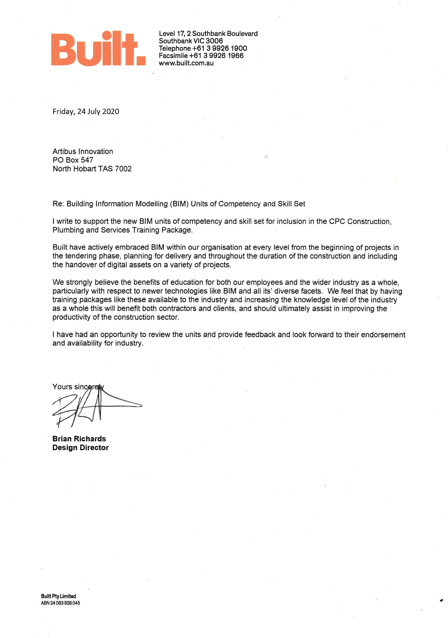

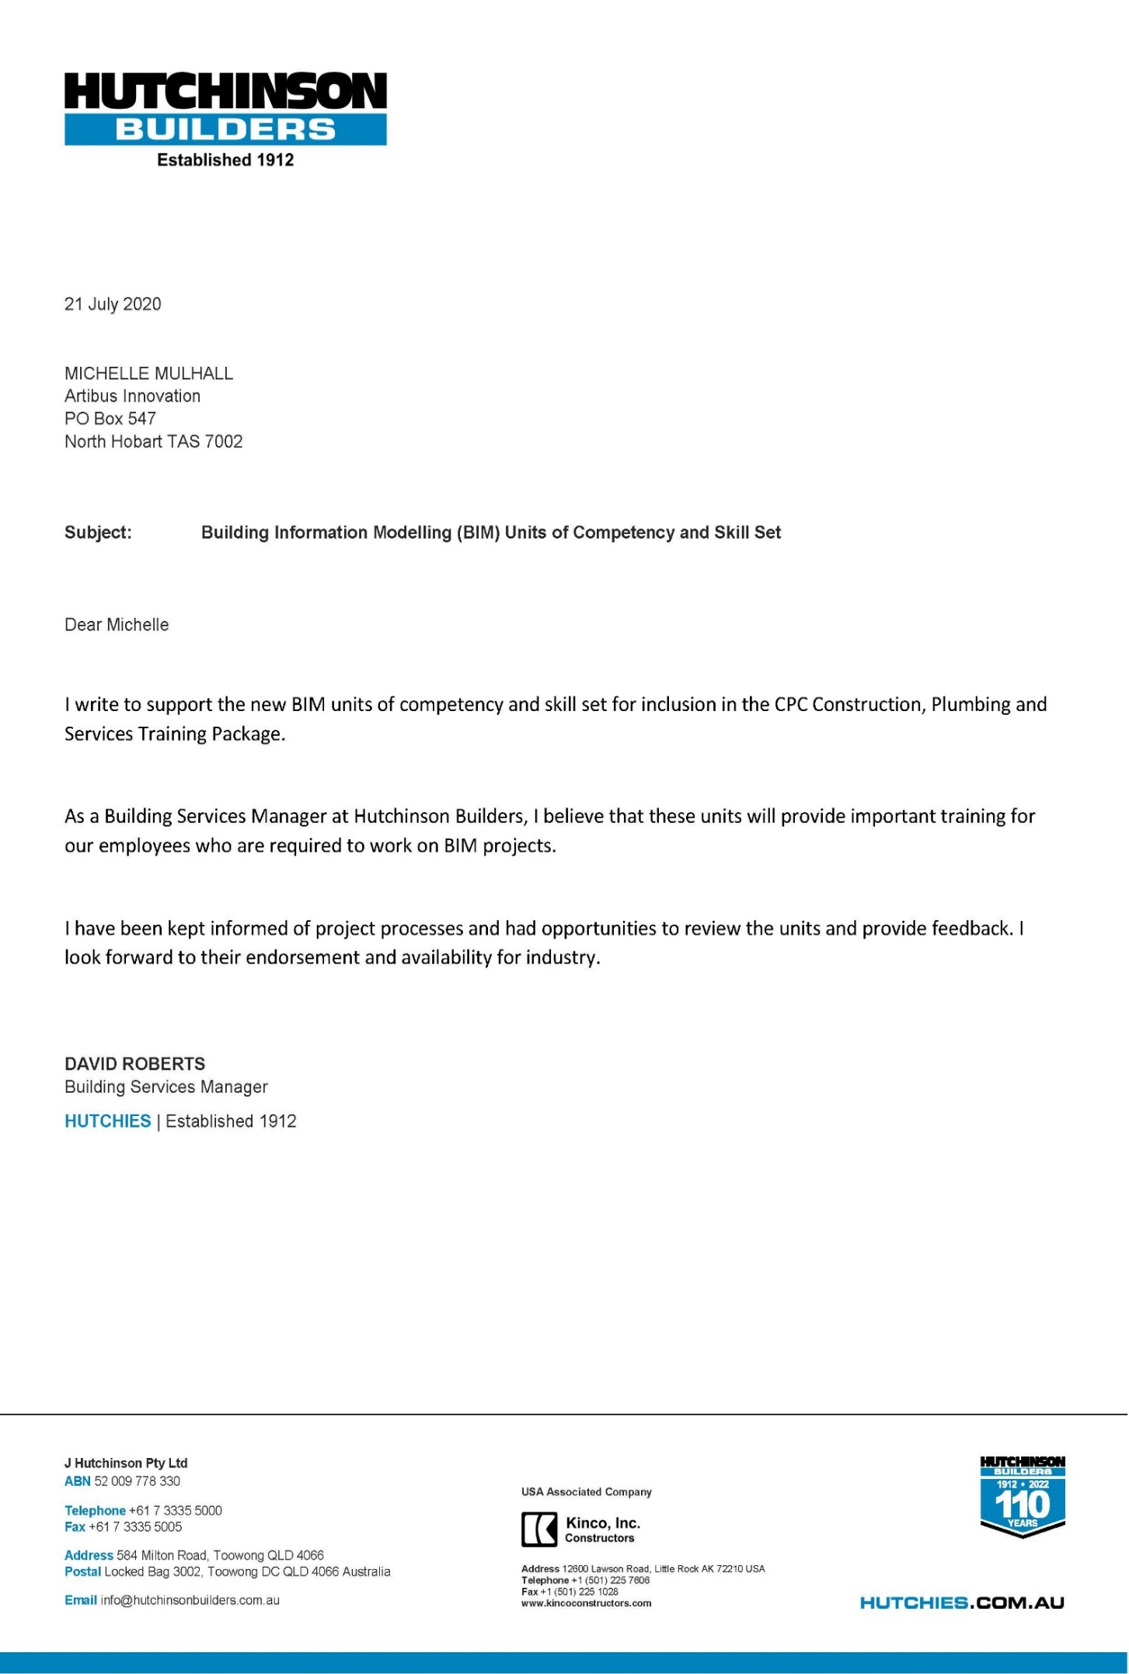

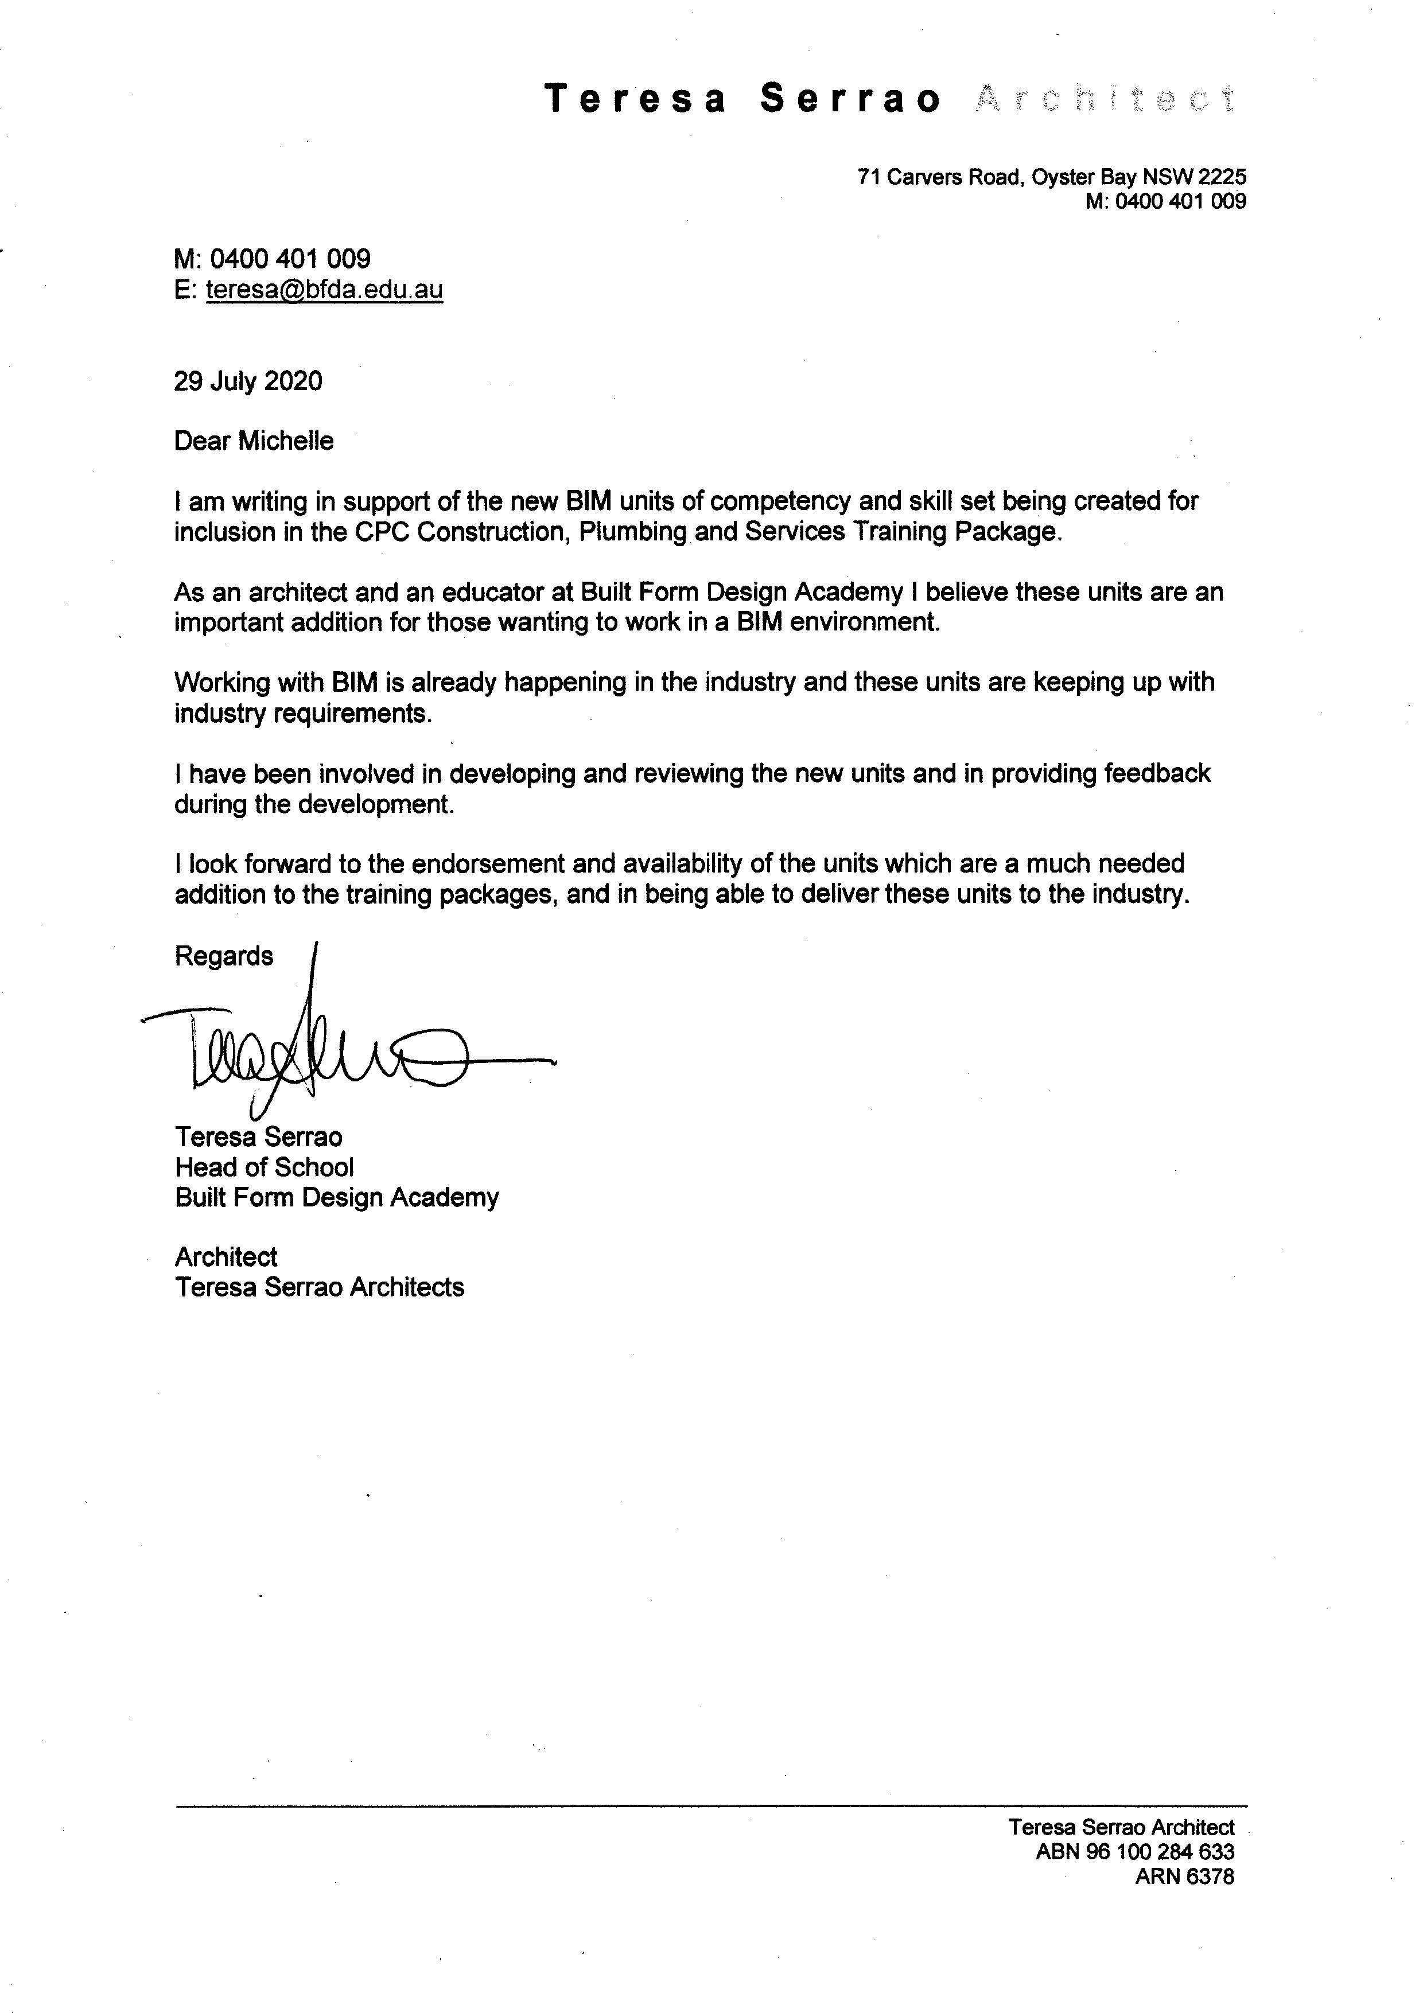

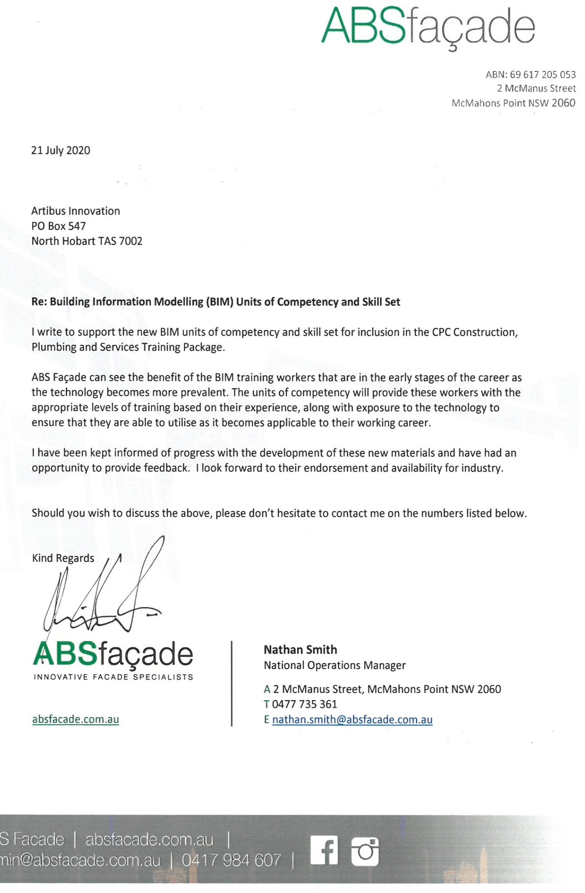

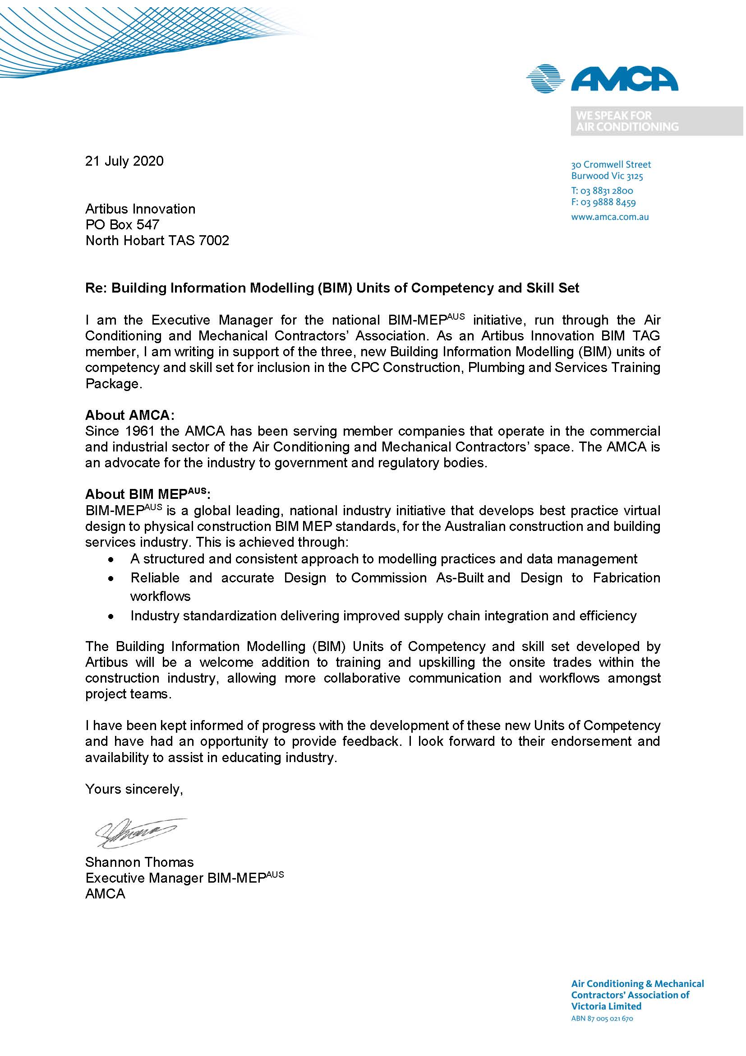

When the number of training products is high the titles can be presented as an attachment.
Persons not a member of the panel are required to demonstrate relevant knowledge and experience in editing technical and industry publications, including details of relevant qualifications and/or professional membership(s).
When the number of training products is high the titles can be presented as an attached list.
Person that is not a member of the Training Package Quality Assurance Panel is required to provide to the SSO information demonstrating experience in analysis of equity issues in the training or educational context; demonstrated understanding of vocational education and training; and details of relevant qualifications and/or professional memberships.

